**RUNNING PYTHON SCRIPT ON VAGRANT SERVER**

FIRST ABLE WE NEED TO ACCESS TO OUR VAGRANT SERVER USING ***vagrant ssh*** COMMAND ONCE WE’VE ACCESSED TO OUR PROJECT FOLDER:

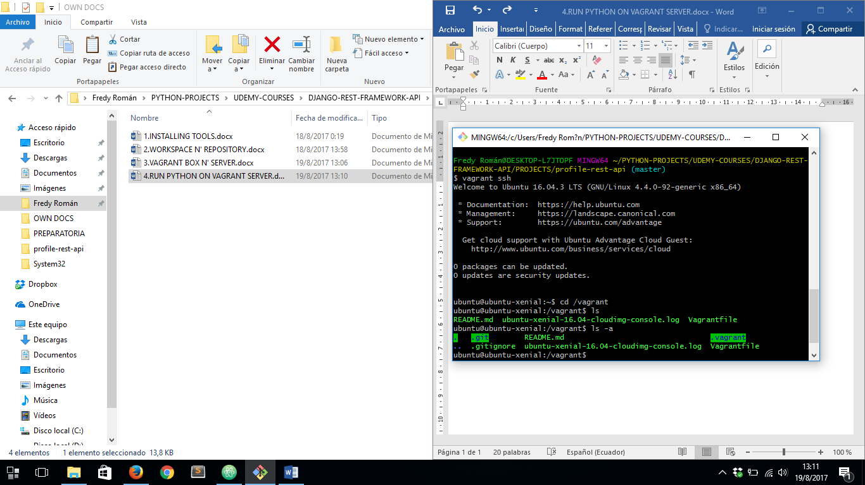

THEN WE MUST ACCESS TO /vagrant DIRECTORY INSIDE OUR SERVER:

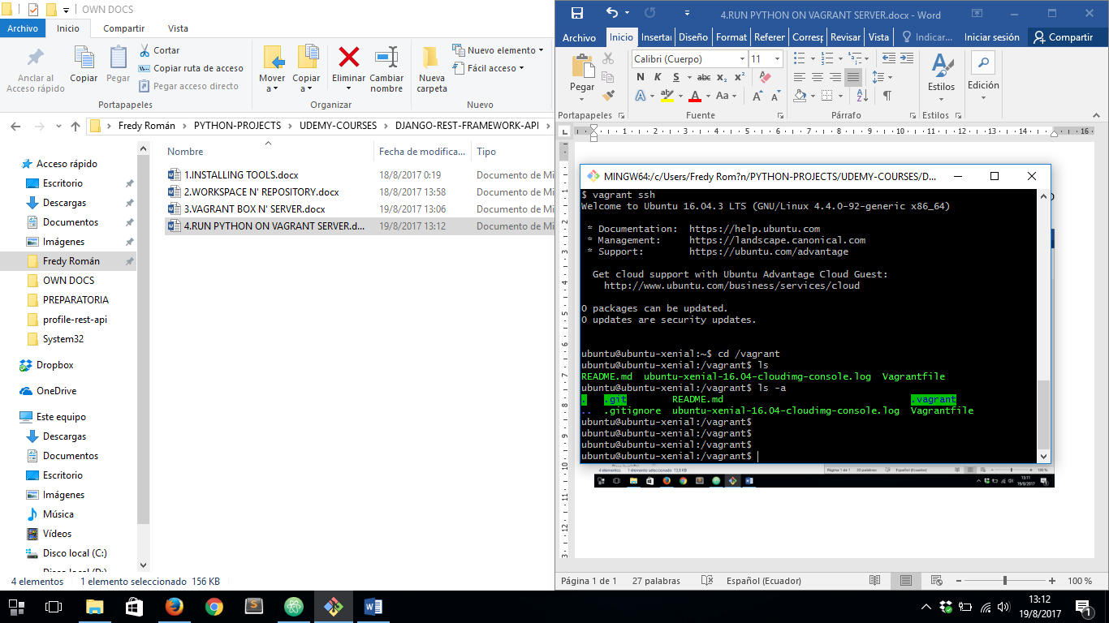

THEN IF WE LIST WITH THE COMMAND ***ls –a*** WE WILL NOTE OUR PROJECT FILES INSIDE OUR LOCAL MACHINE ARE THERE:



IF WE CREATE A NEW FILE INSIDE OUR PROJECT FOLDER NAMED ***hello_world.py*** AND THEN TAKE A LOOK INSIDE OUR ***/vagrant*** DIRECTORY INSIDE THE VIRTUAL SERVER:

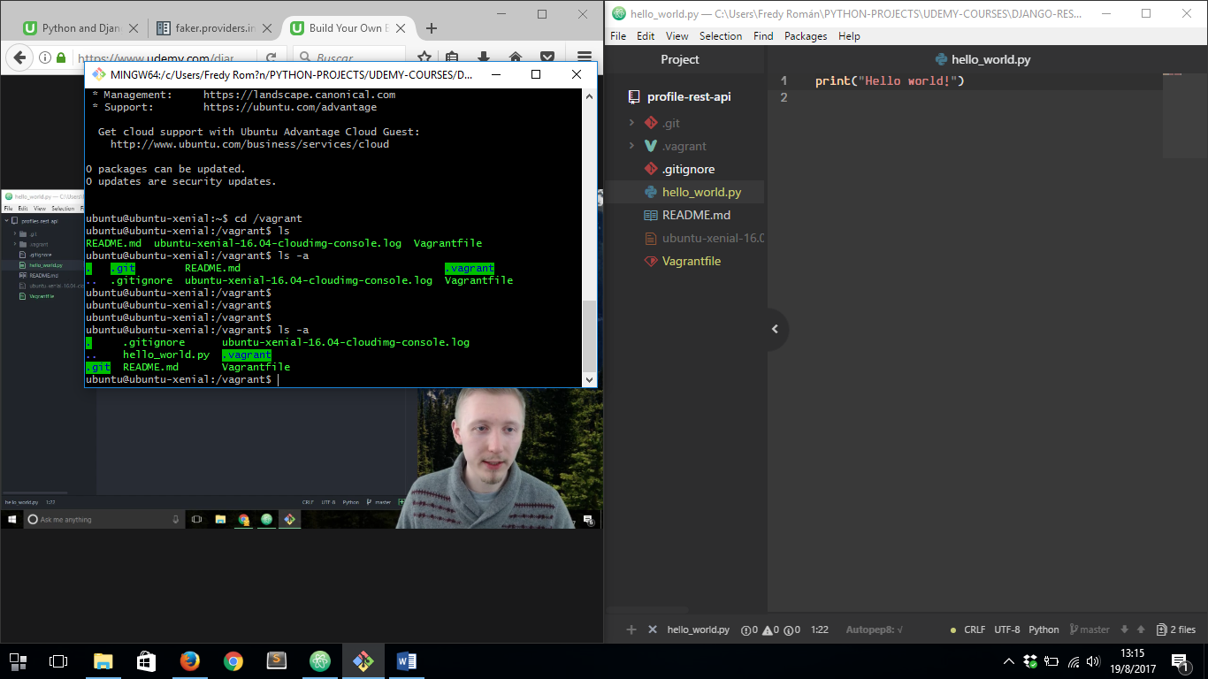

THEN WE ARE GONNA RUN OUR ***hello_world.py*** FILE ON VAGRANT SERVER:

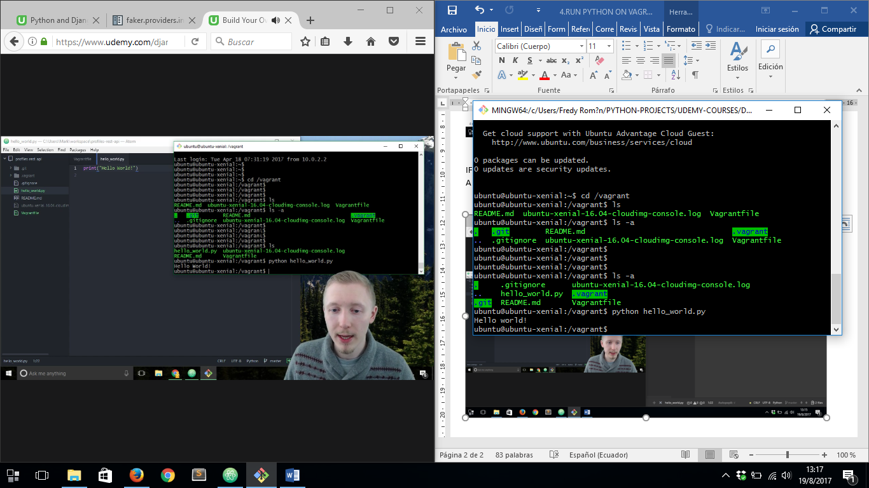

NOW LET’S WORK ONLY WITH LOCAL MACHINE TO MAKE CHANGES TO OUR GIT REPOSITORY, SO LET’S O AHEAD AND OPEN A NEW GIT BASH WINDOW AND LOCATE INSIDE THE PROJECT FOLDER:

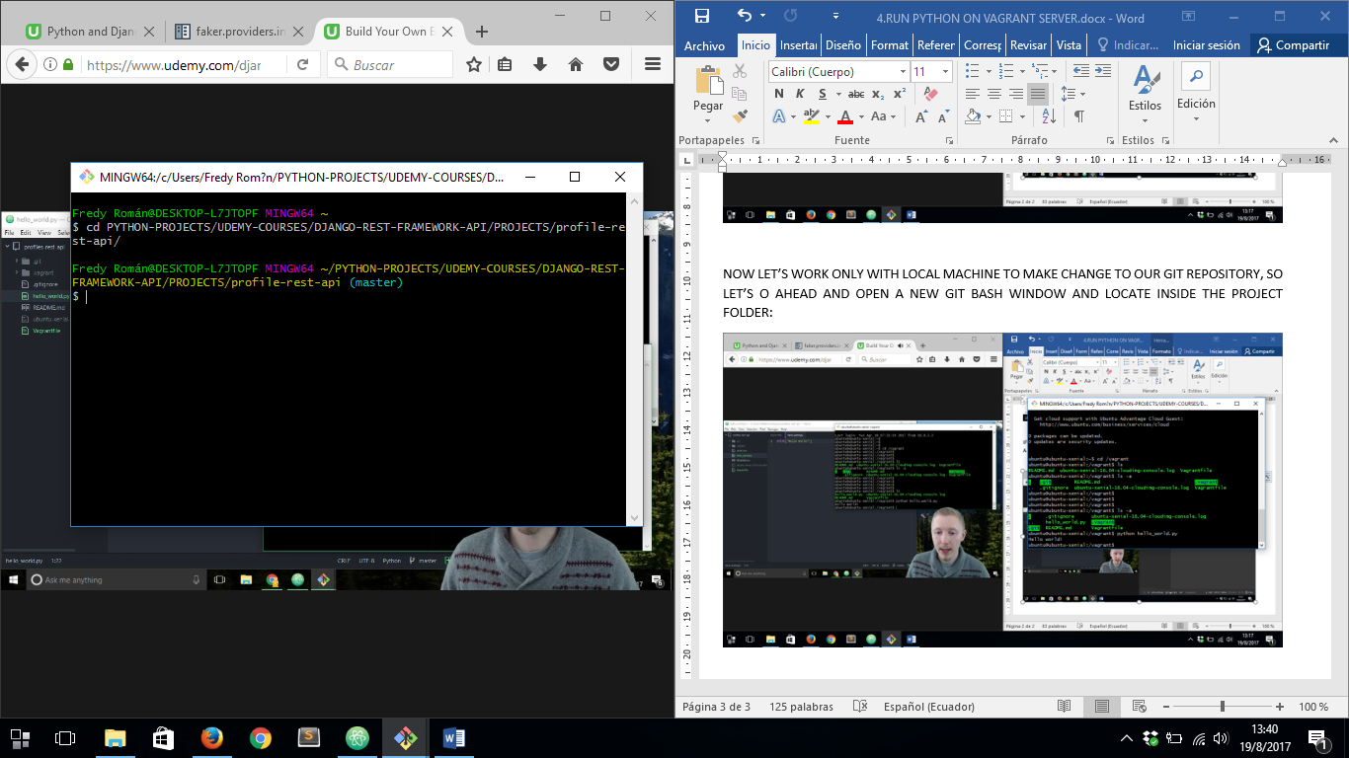

THEN ADD OUR FILES TO THE REPOSITORY AND THEN COMMIT THEM:

